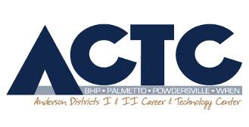

August, 2019

Dear Student and Guardian,

Welcome to the 2019-2020 school year at Anderson 1&2 Career and Technology Center. My name is Lisa Lennon; I am one of five engineering and computer science teachers at ACTC. I teach Introduction to Engineering Design, Environmental Sustainability, Computer Science Essentials and Computer Science Principals at ACTC. Your student is enrolled in the Computer Science Essentials class. Successful completion of the class will fulfill the computer literacy credit needed for South Carolina graduation as stated in the following memorandum from our state department: https://ed.sc.gov/instruction/career-and-technology-education/programs-and-courses/cate-programs/computer-science-hs-memo/
Enrolling in this class also exposes students to computer science education, and upon successful completion, students may elect to follow the computer science pathway offered through ACTC. The courses are Computer Science Essentials, AP Computer Science Principles, AP Computer Science A, Cyber Security, and Computer Controlled Machinery. Additional information about the courses, Project Lead the Way, College Board, and Tri-County Technical College can be found at:
- https://www.andersonctc.org/
- https://www.pltw.org/
- https://www.collegeboard.org/
- https://www.tctc.edu/

I feel it is very important for parents and teachers to communicate. Please do not hesitate to contact me with your concerns. The best way to reach me is through my Remind account (formerly Remind101), however email can also be used, llennon@andersonctc.org. I have set up a Remind account tied to your student’s classroom. In order to sign up for the free service, text ____________ to 81010. I encourage both parents and student to sign up. Messages sent through the Remind account go directly to my phone and show up immediately. This is especially useful on weekends or late evenings when I may not be actively checking email.
I will be using my classroom website to communicate daily agenda items and other announcements, including an electronic copy of the syllabus, to my students. It can be found at our classroom homepage: http://LennonCSEactc.weebly.com. Hard-copies of the syllabus are available upon request for those who cannot access it electronically. Students should be in the habit of checking the website regularly, as it contains information about deadlines, current and upcoming projects, rubrics and more. Students will take most quizzes, tests, and exams electronically. Students and parents are expected to use Power School/Parent Portal to keep track of grades.
I do not expect that EVERY student in my classes will want to become a software developer or hardware engineer. I feel very strongly, however, that experience with computational thinking gives students an advantage when competing for college entry and careers.
Sincerely,
Lisa B Lennon

Attendance in our 2 ½ hour class is very important for a successful experience. Making up 2 ½ hours of work is difficult and not the same benefit as experiencing the instruction with the rest of the class. The following is the A/B schedule for the 2019-2020 school year. Please be aware of your student’s attendance days when setting appointments and scheduling days they will be absent.
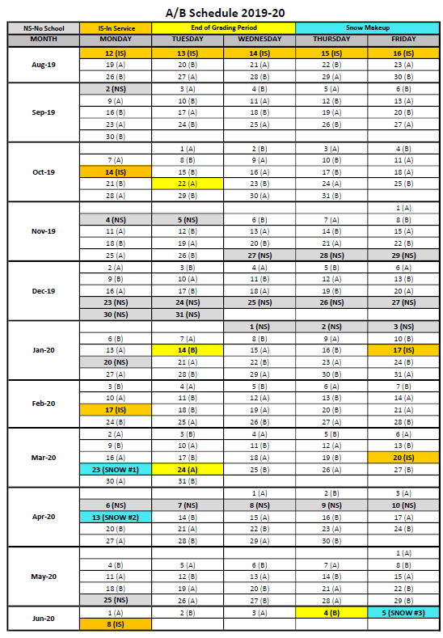

Please sign & return this portion for a grade; maintain the upper portion for your records.
I understand how to contact Mrs. Lennon if I have questions and concerns, and can access the class website for current information. I understand that my student will receive a “20” (100%) in their major grade category when they return this signed portion (in the meantime, a “0” will serve as a placeholder).
_____ Yes, I would like a printed copy of the Syllabus
_____ No, I do not need a printed copy of the Syllabus

Student Name_______________________ Parent signature___________________________
Anderson 1 & 2 Career and Technology Center

Computer Science Essentials (CSE)

Course Syllabus

Instructor: | Lisa B Lennon

Available for Conferences: | After regular school hours

Text: | None

Course  Description: | Computer Science Essentials introduces students to coding fundamentals through an approachable, block-based programming language where they will have early success in creating usable apps. As students sharpen their computational thinking skills, they will transition to programming environments that reinforce coding fundamentals by displaying block programming and text based programming side-by-side. Finally, students will learn the power of text-based programming as they are introduced to the Python® programming language. The course engages students in computational thinking practices and collaboration strategies, as well as industry-standard tools authentic to how computer science professionals work. Students will learn about professional opportunities in computer science and how computing can be an integral part of all careers today.

Method of Evaluating Students: | Major Grades (Projects/Quizzes/Daily Grades) = 60%  Minor Grades (Notebook/ERS) = 40%

Instructional Philosophy: | By using an activities, project, & problem based learning approach in the classroom students will be better prepared to:  - Demonstrate an understanding of subject content  - Investigate and engage in meaningful activities,  projects, and problems  - Become independent learners  - Make their own connections between posed questions and  prior learning  - Use real life technologies and resources  - Obtain ownership of their learning  - Exhibit growth in areas often ignored: social and life skills,  self-management skills, and the ability to learn on one’s own.

Materials:  Fees: | Bring a pen and a pencil daily.  The course fee is $20. There is a link on the AndersonCTC.org homepage for electronic payments. If you prefer to write a check, make it payable to ACTC.

Course Goals: | The goals of this course are:  - To introduce students to the fundamentals of programming.  - To prepare students for the CS pathway by introducing them to the CS K12 frameworks, the CSTA K-12 CS Level 3A standards, and the AP CSP frameworks.  - To teach students the skills and tools to express themselves creatively through programming, app design, and web development.  - To introduce students to block-based and text-based programming used in careers around the globe.  - To get students excited about a career in technology.

Classroom Procedures: | - Be on time and prepared for class.  - Be prepared to actively participate in class.  - Students will follow all written and oral directions and safety precautions.  - Complete all assignments in a timely fashion. You must work diligently to stay caught up.  - Be respectful of others and their property.  - Take care of the learning environment. Keep your area neat and clean. Always clean your space before you leave for the day. Put materials away in their proper place.  - Get the instructor’s permission before obtaining materials from any storage area.  - Get the instructor’s permission before leaving the classroom.  - Cheating will not be tolerated. Students found cheating will receive a zero for that assignment. The instructor and/or school will decide any further course of action.

Computer Lab Procedures: | - Do not change any of the settings on the computers.  - Do not download programs (including games) to the computer.  - Do not access inappropriate content on the internet.  - Take care of the learning environment. Keep your area neat and  clean. Always clean your space before you leave for the day.

Make-up Policy: | Students are responsible for makeup work when absent. Each student will have 2 career center school days to make up missed work.

Instructional Delivery Plan: | Instructional delivery will vary including, but not limited to: traditional lecture, Socratic lecture, demonstration, inquiry activities, hands-on activities, group activities, and individual activities.

Consequences: | - Verbal Warning  - Conference with Student & Contact Parent  - Loss of Break Time, Written Referral  - Removal from Classroom  - If a student acts in a manner that is totally unacceptable or unsafe, he or she may be immediately removed from class with a disciplinary referral.

Content  Outline: | Unit 1 Creative Computing: Building with Blocks  Unit 1 welcomes new and returning students to the world of computer science and coding fundamentals. Students work with MIT App Inventor to create basic apps that rely on the concepts of event-driven programming,  branching, iteration, variables, and abstraction—the building blocks of creating with code. Students are introduced to essential computational thinking practices, such as developing abstractions, collaborating around computing, and communicating as they create, test, and refine computational artifacts of Android™ apps.  Unit 2: Computing and Society: Transitions to Text  Unit 2 continues to reinforce coding fundamentals as students are gradually introduced to text-based programming. In this unit, students will explore the impacts of computer science on our society and bring coding off the screen  and into the physical world. Students will learn how images can be used to make decisions in programs and explore real-world applications and innovations that will shape our future.  Unit 3 Solving with Syntax  The goal of Unit 3 is for students to begin to understand and use the flexibility and power of programming in a text-based environment. Students will be introduced to the Python® programming language in the collaborative  Cloud9 development environment. In this unit, students will continue to build on coding fundamentals as they apply the same coding concepts, computational thinking practices, and development processes introduced in  units 1 and 2.  Unit 4 Computing with a Purpose  The final unit in CSE allows students to apply all that they have learned in a student-defined, student-driven development. Whether creating an app, a website, or a physical computing device, students will apply computational  thinking practices and a strategic development process to create computational artifacts that solve problems and create value for others. Students will collaborate the way computing professionals do as they pursue solutions to authentic needs. For those students continuing on to AP CSP, this unit provides an excellent model of how to participate in, document, and create a performance task for AP CSP.

